Error en el Script NSeComm | Punchout2Go Invoice:
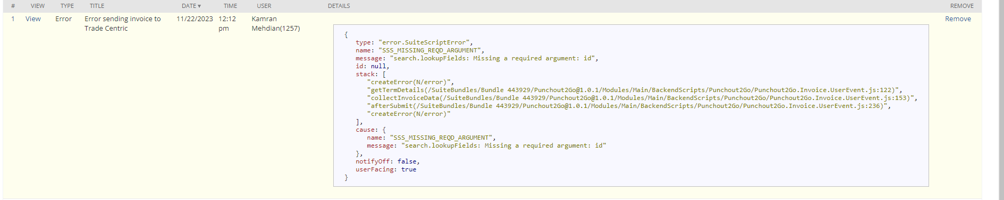

Repro steps:
Developer -> PunchoutNow -> PunchOut session -> redirect to nssb.asucla.ucla.edu -> enter kids-youth
Add to cart ucla youth ball in basketball tee -> transfer cart

Then leads you to tradecentric -> convert to order -> update -> send. This will create the sales order.
Then check for the last sales order created
- Transaction -> Sales -> Enter sales order -> list -> select last sales order
- Press on Fulfill -> this will open up an Item Fulfillment.
- On the item fulfillment -> press “ship” -> press “bill” -> this will open up a new invoice
- On invoice -> fill up “terms”, “Shipping method” and “shipping cost”
- Go back to sales order, and press on tab: related records -> open the item fulfillment
Press on fill -> se habre un invoice y guardo.

Errors found:
- Fill up terms on invoice
- API key missing
- Change the URL from the script to the Staging URL.

Solution: Set the API key, it was not being get by the script somehow.

